Rownhams st john’s Ce Primary school
Prospectus 2016-17
  - 2015-2016
[You can add an abstract or other key statement here. An abstract is typically a short summary of the document content.]

Introduction 1
Welcome to our school! 1
Admissions 4
Safeguarding 4
Who’s Who at Rownhams School? 4
Being a church school 2
What is a church school? 2
RE and Collective Worship 2
SIAMs 3
Teaching and Learning 4
Class Structure 4
The Curriculum 5
Individualised Learning Error! Bookmark not defined.
PSHE 8
Home Learning Error! Bookmark not defined.
Life in School 8
Attendance 8
Behaviour in school 9
Transport 10
The school day 11
Educational Visits 13
Community Links 13
Moving through school 14
Equipment and resources 16
Illness and medicines 17
The Home-School Partnership 18
Family learning 18
Communication 18
Rownhams School Association (FORCE) 19
Helping out in school 20
Leadership and management 20
School Performance 20
School Development Plan 22
The Governing Body 23
Access to Official Information 24
Appendix 1: Term dates 25
Academic year 2015-2016 25

Introduction

Welcome to our school!
Thank you for taking the time to look at our school’s prospectus. We hope you find the information helpful and informative – but we would like to encourage you to contact us directly if you would like to find out more. We are always delighted to meet with new and prospective parents – to share both our children’s’ learning and our wonderful learning environment!
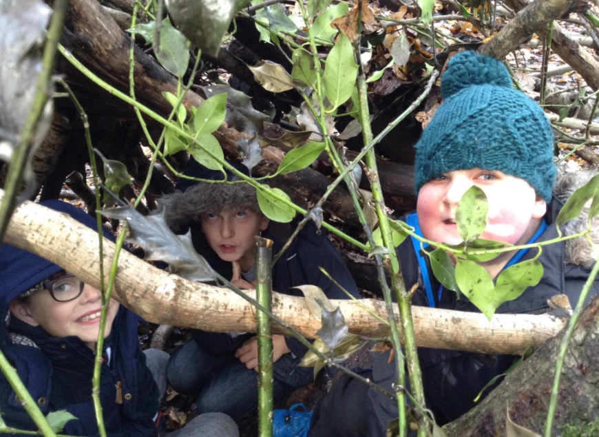
We look forward to meeting you!

Butterflies, butterflies everywhere!
When you walk around our school it is likely that you will notice our special butterfly motifs – they appear in our displays and various other places in school. The metaphor of children being like butterflies was inspired by this anonymous poem:

A child is like a butterfly in the wind
Some can fly higher than others
But each flies the best it can.
Why compare one against the other?
Each one is different!
Each one is special!
Each one is beautiful!

The children developed their thinking from this poem and talk about being like butterflies because they:
- are beautiful, special and unique
- are fragile – just like the butterfly’s wings
- want freedom and like the idea of being able to fly
- dream of where they might travel to
- reach high to achieve their dreams
- want to be able to cope with change - as well as the butterfly copes with changing from a caterpillar into a chrysalis into a butterfly
- transform during their time at Rownhams St John’s School
- need protection just like we need to protect a butterfly’s habitat
- can fly higher and higher to escape from their troubles
- want to contribute to their community by doing something useful just like a butterfly pollinating flowers
- are part of God’s creation just like a butterfly!

Vision and Values - Loving life; loving learning
Our aim is to develop children who have the spiritual and moral depth to forge their own path in this changing world; they will have strong values and principles and will be able to make decisions in line with these.
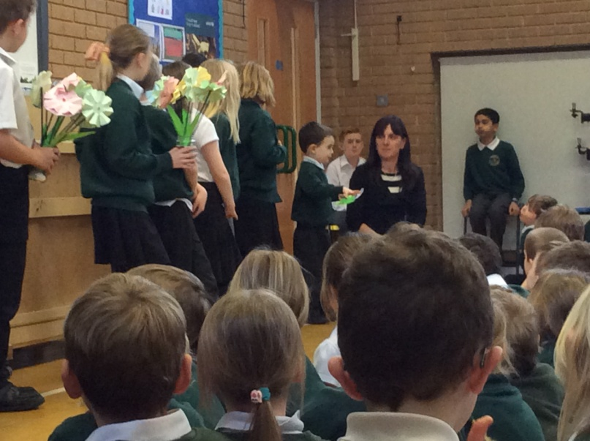
In the future, our children will experience rapid change, global competition and uncertainty. It is our responsibility to prepare them for this, helping them to develop the values, skills and personal qualities to be confident, responsible and successful citizens. Our school serves the community by providing education of the highest quality within the context of Christian belief and practice. We encourage an understanding of the meaning and significance of faith and promote Christian values.
Our school is a place where everyone is safe, happy and confident that they will achieve their best. It is a place where individuals learn to love themselves, one another and the world around them; a place where church and community links are purposeful and strong; a place where love, joy and responsibility are not just words, but a way of life.
We believe that everyone is a learner for life and everyone is unique and special. We encourage learners to develop their own lines of enquiry and interests. Our school is a place where it is safe for all to express opinions, make mistakes, ask for and receive help. We will guide our children in developing positive self-esteem, respect for others, tolerance, and a keen sense of justice and integrity. We will encourage them to understand their responsibilities and to develop good emotional intelligence, being able to understand their own feelings, and those of others. We understand the importance of good physical and mental health in achieving success, and we will support our children in maintaining this.
Our children set themselves challenging, yet realistic, expectations. They are resilient and have the confidence to take risks in their learning. They can evaluate their learning and take decisions about how they learn best, which helps them to develop an enduring love of learning. They are adaptable and comfortable working both independently and collaboratively.
Our curriculum is inspiring, innovative and creative. It focuses on developing excellent skills in communication, reading, writing, mathematics and ICT. Our curriculum has been designed to prepare learners for a life in our changing world by developing thinking and learning skills that they will always be able to use and by encouraging the use of new ideas and technologies.
Our group of Teaching and Learning Young Governors (more later) worked with the vision statement and summarized it into the following acrostic which sums how they think all at Rownhams should be:
Respectful and Reliable
Optimistic and Outstanding
Welcoming and Wonderful
Nurturing and Numerate
Honest and Happy
Aspirational and Adaptable
Motivated and Magnificent
Spiritual and Special

Facilities and Resources
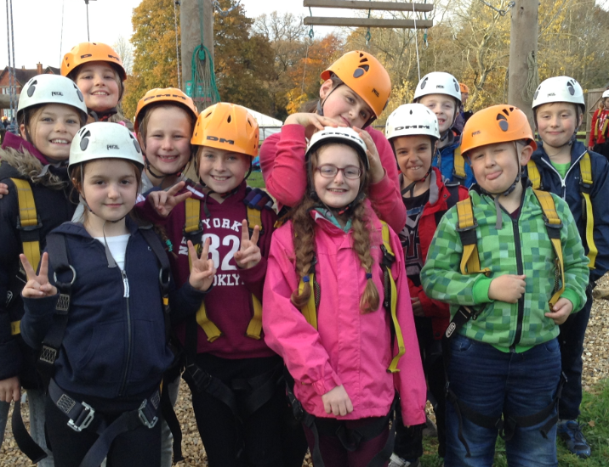
We are committed to providing the children in our school with high quality up to date resources. We pride ourselves on the beautiful school environment, with a state of the art library (redeveloped during the summer of 2015), recently refurbished and well maintained classrooms, a specialised and well-resourced Special Educational Needs room (the Aviary), a specialist music room with a large collection of musical instruments, access to cookery equipment and a fabulous outside environment, with plenty of space to learn and play.
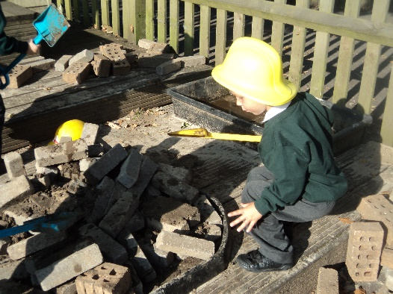
Sunny sports day on the school field

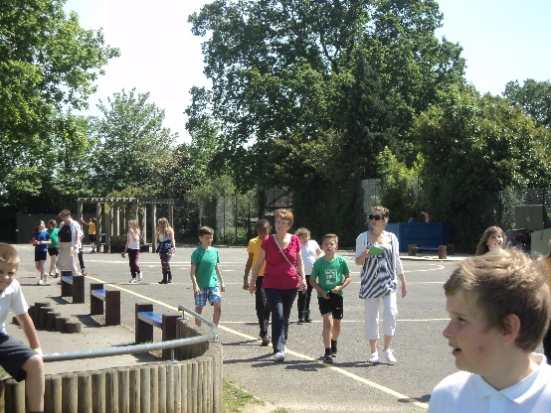

Our children are currently involved in the redevelopment and improvement of our facilities – as, after all, they know what works better than most!

Admissions

The school adheres to the Hampshire Local Authority admission arrangements. Full details of admission arrangements become available in the autumn term, the year before a child is due to start school. All applications are made online, through the Local Authority’s admissions process.
Children are admitted to school at the beginning of the academic year in which they turn five. If you have a young child and would like them to come to our school, we encourage you to come and visit us once your child has had their 4th birthday. If you contact the school office, they will be delighted to arrange such a visit for you.
The latest Admissions Policy can be found on our website or on the Hampshire County Council website.
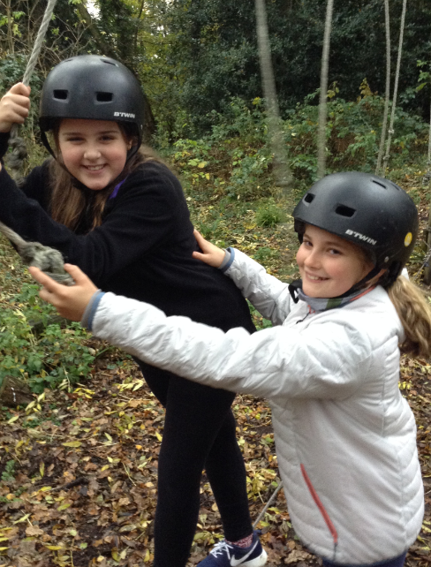

Safeguarding

The school has a robust Child Protection Policy and follows Hampshire County Council Procedures regarding child safety and welfare. By following these procedures, the school has a duty to refer any serious concerns about the well-being of pupils to the Children’s Services Department

The safeguarding policy and child protection policy can both be found on our website.

Who’s Who at Rownhams School?

Leadership team
MR TIM WOODFORD  Headteacher |  | Mrs jane smith  deputy headteacher & Inclusion leader
 |  | 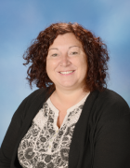
t.woodford@rownhams.hants.sch.uk |  | j.smith@rownhams.hants.sch.uk

Staff
Teaching Staff (EYFS/KS 1) Helen Hannam (Y2) (EYFS/KS1 Leader)
Karen Johnson/ (Y2)
Natalie Alldred (Y2)
Abbey Ramsdale (YR/1 leader)
Jodie Robus (YR/1)
Kirsten Knight (YR/1)

Support Staff (EYFS/KS1) Fiona Alexander, Tracy Barratt, Helen Poulter, Kelly Herridge, Lisa Cobb

Teaching Staff (Lower KS 2) Katherine Hill (Y3/4 leader) Simon Warner (Y3/4)
Abby Hogbin & Mel Garrod (Y3/4)
Support Staff (Lower KS2) Gurcharan Shahi, Sally Stride (ELSA), Claire Renyard, Jo Moroney, Marie Wilson, Claire Stride
Teaching Staff (Upper KS 2) Lisa Phillips (KS2 Leader)
Marie Withers (Y5/6)
Sarah Phelps & Hayley Adams (Y5/6)
KS2 Maths Teacher Hilda Kinnis Robson
Additional 1:1 Teacher Anne Tree
Support Staff (Upper KS2) Sue Valois, Chris Mason, Kelly Noel , Su Mukherjee
Child and Family Support Worker Shirley Jonas (ELSA)
Admin Officer Fiona Hoggarth
Finance Admin Assistant Lynne Tongs
Admin Assistant Sheryl Wilkins
Lunchtime Staff Chris Mason, Sue Valois,Gurcharan Shahi, Kelly Bampton, Sharon Garrathy, Sharon Horn, Karen Croome, Lesley May-Hurst, Sarah Seymour, Ann West ,

Cleaning/Caretaking Staff Jamie Stokes, Lesley May-Hurst, Sarah Welch, Brenda Ridout, Patricia Richards

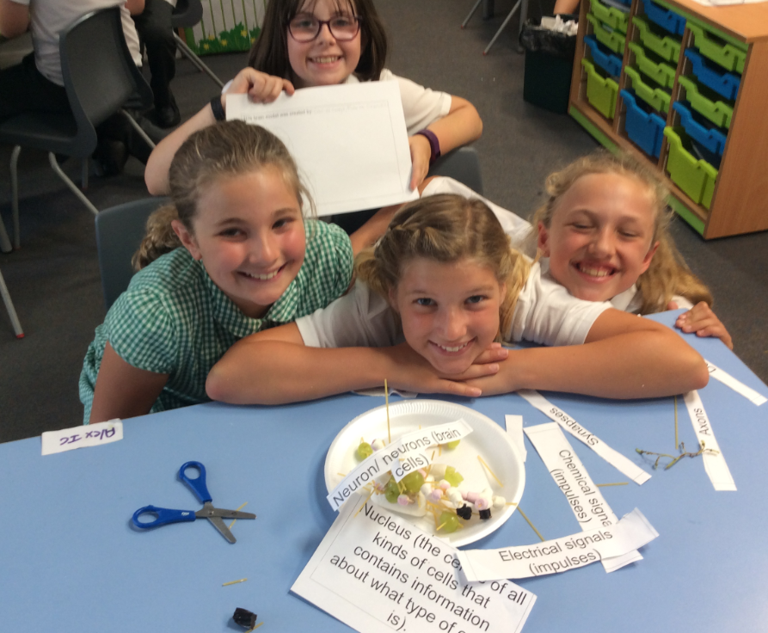
All staff at Rownhams Primary School have been required to complete a Declaration of Pecuniary Interests. There are no staff at Rownhams Primary School who have themselves, or have a partner of or any close relative who has a significant interest in any organisation that may supply goods or services to the school.

Useful addresses

School
Rownhams St John’s CE Primary School
Bakers Drove
Rownhams
Southampton
SO16 8AD
Tel. 02380 736417
Email. adminoffice@rownhams.hants.sch.uk

Chair of Governors
Andrew Brown
25 Bridgers Close
Rownhams
Southampton
SO16 8DU
Tel. 02380 736417

Director of Children’s Services
Steve Crocker
Director of Children’s Services
County Office
The Castle
Winchester
SO23 8UG
Tel. 01962 841841

Vicar – St John’s Church
Rev. Julian Williams
The Vicarage
Horns Drove
Rownhams
SO16 8AH
Tel. 02380 738293

Being a church school

What is a church school?

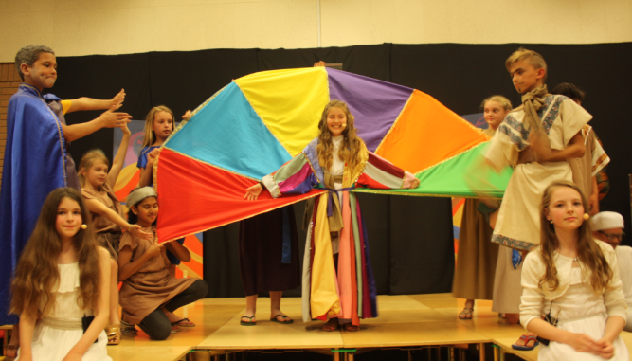
“A community school with a distinctive Christian character.”

Before the government became involved with providing education for everyone in England – there were church schools and other charitable schools.
The majority of church schools were built in the 1800’s and most have the following or similar words in their trust deed.

“a School for the instruction of children and adults or children only of the labouring manufacturing and other poorer classes in the parish of . . . . .”
Church schools are encouraged to:
• ensure that the school is led by a headteacher who is committed, with the help of staff, to establish
and maintain the Christian character of the school in its day to day activities and in the curriculum
• engage meaningfully in a real act of Christian worship every day
• offer a school life that incorporates the values of the Christian faith
• ensure that religious education is given at least 5% of school time and that the character and quality of religious education are a particular concern of the headteacher and the governing body
• observe the major Christian festivals and in schools in which other faiths are present ensure that those faiths are able and encouraged to mark their major festivals with integrity
• maintain and develop an active and affirming relationship with a parish church
• proclaim that it is a Church of England school on its external signboard and on its stationery and make appropriate use of Christian symbols inside and outside the school.

RE and Collective Worship

Collective Worship
We hold a daily act of Worship. This worship is Christian in character, reflecting our nature as a church school. Worship is led by a variety of people, including staff, visitors and children. During worship, we share stories from the Christian faith, and from other cultures, in order to encourage children to think about the world they live in.
Parents have a legal right to withdraw their children from this daily worship. This should be put in writing to the headteacher.

Religious Education
The RE curriculum (Living Differences) encourages children to understand religions and what is distinctive to each. In addition to learning about distinctive Anglican beliefs and practices, Judaism, Islam and Hindu faiths are also currently explored – every faith matters.
RE teaching contributes to a consideration of a range of moral and religious issues and to developing children’s understanding and respect for a range of beliefs, cultures and societies.

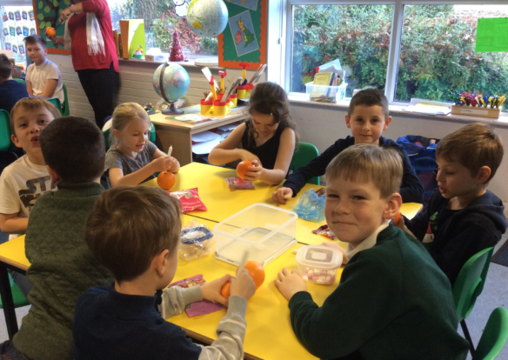
SIAMs

National Society Statutory Inspection of Anglican and Methodist Schools (SIAMS) February 2015
These inspections are carried out every 5 years to externally assess the quality of Anglican and Methodist schools. Our overall grading at our most recent inspection in February 2015 was GOOD.

During the inspection staff, governors, parents and children who were part of the process, impressed the inspector with their honesty, engagement and support of the school.

The areas identified for improvement reflected what we, as a leadership team, had already identified and have on our action plan for school improvement.

Teaching and learning
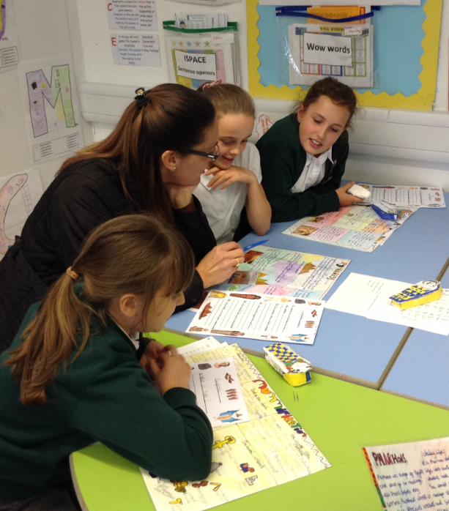
Children are best able to fulfil their potential when they feel valued and have high self-esteem. We encourage the children at our school to develop positive relationships with their peers and the adults who help support them in their learning and their social and emotional development.
We seek to foster a strong work ethic and motivate our children through praising effort and achievement.
We take account of both effective, traditional teaching methods and the findings of current research into how children learn, and we use this to optimize the quality of the teaching our children receive.

Class Structure

RSJ admits children between the ages of 4 and 11 years. The standards admission number is 40 in EYFS and KS1 and 45 in KS2. Our school is divided into 11 classes.
Within year groups, class teachers work cooperatively when planning and structuring children’s learning. They use a variety of teaching styles and organization in order to achieve the best for the children. This means that sometimes children are taught as a whole class, sometimes in groups and sometimes individually.

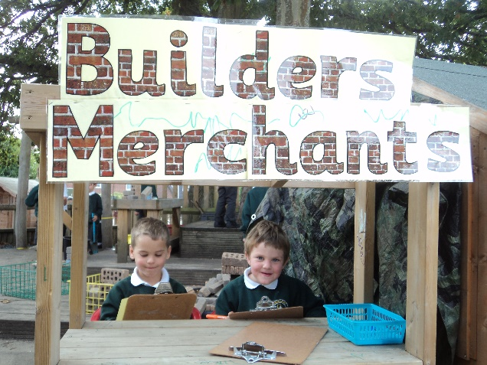
EYFS/KS1
We have three mixed Reception/Year 1 classes (4-6 years old), taught by Miss Hill, Miss Robus and Miss Ramsdale. We have two Year 2 classes (5-7 years old), taught by Mrs Hannam and Mrs Alldred/Mrs Johnson.
Mrs Barratt, Mrs Maxwell, Mrs Alexander, Mrs Poulter, and Mrs Renyard provide additional learning support for the children in this phase.

Lower Key Stage 2
We have three mixed Year 3/4 classes (7-9 years old), taught by Mrs Phillips, Mr Warner and Miss Hogbin/Mrs Garrod,
Mrs Stride, Mrs Shahi, Mrs King and Mrs Sturrock (HLTA) provide additional learning support for the children in this phase.

Upper Key Stage 2
We have three mixed Year 5/6 classes (9-11 years old), taught by Miss White, Miss Withers and Mrs Phelps/Ms Adams.
Mr Brown and Mrs Valois provide additional learning support for the children in this phase.

Our SHARK Curriculum

Children get just one childhood: it should be a magical and happy time and their primary education should leave a host of positive and meaningful memories that last for the rest of their life. Will Ryan

We believe that education should prepare our children for their future. It should give them the best possible start - a childhood that they can build on for the rest of their lives. We teach the children skills they need, help them to develop habits and attitudes to enable them to become good learners for life and encourage them to take responsibility for everything they do. We do this through the implementation of our SHARK curriculum.
We are what we
repeatedly do. Excellence,
then, is not an act but a habit.
Aristotle

S- skills

H- habits

A- attitudes

R- responsibility

K- knowledge

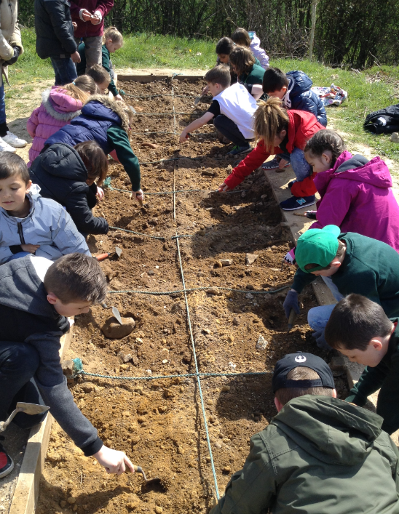
The curriculum content is based on the National Curriculum 2014 and learning is organized into learning units which engage the children through exciting hooks and work towards a purposeful outcome. The children get involved in the planning of their learning which enables them to become motivated learners and great thinkers.

Growth Mindsets

In a growth mindset students understand that their talents and abilities can be developed through effort, good teaching and persistence. They don’t necessarily think everyone’s the same or anyone can be Einstein, but they believe everyone can get smarter if they work at it. Carol Dweck

Here at RSJ, we encourage the development of growth mindsets to encourage children to recognize that their intelligence can grow and is not fixed. We teach the children that by working hard at their learning and by practising skills, they will make progress and can get better and better – there are no limits to what they can achieve.
The adults at RSJ work hard to provide opportunities to extend and enrich the curriculum for all children. By creating challenging learning opportunities children learn to develop growth mindsets, stick at something, cope with failure and recognize that they can achieve at their own speed and progress in their own way.
Children are encouraged to share their interests, abilities and skills with each other and a wide range of challenges are offered throughout our local pyramid of schools. Home learning opportunities also offer challenges to extend their interests and thinking.

Inclusion
Children have a learning difficulty if they have a significantly greater difficulty in learning than the majority of children of their age, or a disability which prevents or hinders them from making use of educational facilities of a kind generally provided in schools for children of their age.
All children are entitled to a broad, balanced and relevant curriculum throughout their school life and are encouraged to take part in all areas of school life: our policies are inclusive of children of all abilities and backgrounds.
The main aim of our school Special Needs policy is to ensure that learning support programmes are in place for children who have particular needs and that they have access to their full entitlement to the whole school curriculum.
All children learn at different rates and the learning throughout the school is planned at a level for all children to make good progress. Where children, through constant monitoring of their progress, are identified as having special needs, then the school has staffing and resources to support them.
At all times the involvement of parents is essential. The concern for these children will form a partnership between teachers, parents and other professionals (eg Educational Psychologist, Speech therapist). We have a large team of well-qualified LSAs (Learning Support Assistants) who work throughout the school with children of all abilities, giving additional help where most appropriate – this includes support for physical, learning and emotional needs (ELSA support). Our school is inclusive in approach and we aim to do our best to meet the varying needs of all children. Rownhams St John’s CE Primary School wants to achieve this effective partnership with parents through open, honest and sensitive communication. Teachers will involve parents in discussions about the child’s difficulties at the earliest opportunity and they will then work together to overcome them.
The work of the Learning Support team is co-ordinated by the Inclusion and Special Needs Co-ordinator (InCo) Jane Smith, and training is regularly undertaken by all staff concerned.

Equal Opportunity
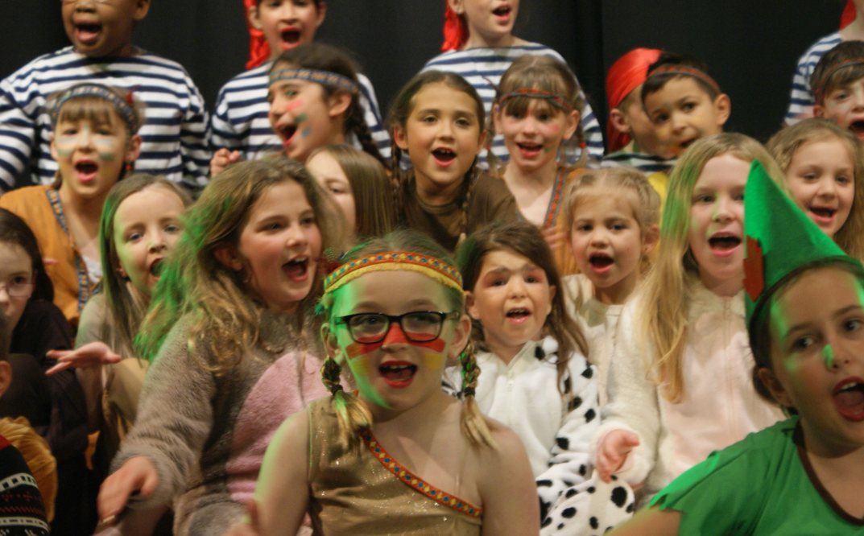
At RSJ our aim is to provide equality of opportunities for all children to participate in every aspect of school life, paying due regard to health and safety and pupils’ age, aptitude and attainment. We recognise that individuals are unique and have differing needs. We are committed to equality of opportunities for all pupils irrespective of gender, race, disability or socio-economic background and recognise that discrimination, whether open or masked, can lead to inequality of educational opportunity and therefore strive to ensure that the potential of all pupils is maximised. We believe that low expectation and underachievement limit pupil potential and we therefore set high standards for everyone. Children with disabilities will not be treated less favourably and will have their needs met through a range of strategies and processes.

Working with other agencies
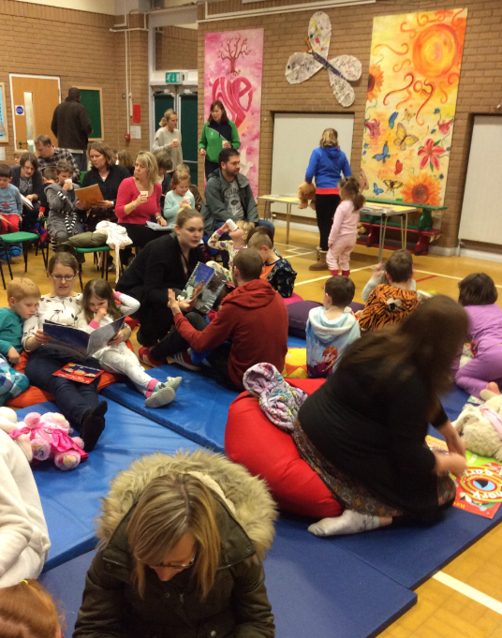
From time to time we may need to work with other agencies to provide support for a child. These may be Social Services, Speech and Language Therapy, Educational Psychology, Occupational Therapy and the Behaviour Support Team. Parents will always be consulted before such contact is made.

PSHE
All children take part in a planned programme of personal, social and health education.

Sex and relationships education
The governors have decided that Sex and Relationships Education should be a part of the curriculum at RSJ. They support the recommendation of Hampshire Education Committee that Sex and Relationships Education should be part of the Personal and Social and Health Education of all pupils. The PSHE Scheme of Work ensures that Sex and Relationships Education is taught throughout the school. Sex and Relationships Education has been woven into PSHE to allow continuity and progression across the curriculum and to make it appropriate to different year groups from Reception to Year 6. Issues such as: special people, friendships, personal hygiene, birth and reproduction, peer pressure and self respect are covered.

Parents/carers who require further information about the content of the detailed planning programme for all children should contact the headteacher and copies are available on request.

Life in school

Attendance
Good attendance and punctuality are crucial in allowing your child to get the most out of their time at school. We are required by law to record your child’s attendance on the register, and this is frequently checked by the headteacher. If there are concerns about a child’s attendance, these will be shared with parents, in order to seek improvements.
It is very important that we promote good attendance. Our statistics are recorded and reported upon to the DfE annually. The Education Welfare Service (EWS) in Hampshire may choose to issue penalty notices for unauthorised absence in excess of the permitted threshold. Authorised absence from school is when a child is away from school due to illness and notification is received to confirm this, or a request for absence is approved by the Headteacher in exceptional circumstances only (from September 2013 there is no longer provision in law for Headteachers to authorise absence from school for the purpose of term-time holiday.)

We do not want to be in a position of a penalty notice being issued to any parent at RSJ and this can be achieved by ensuring term-time absence is kept to a minimum.

If your child is unwell and unable to attend school we ask that you inform the office by 10.00am. We ask that you provide a covering letter on the day of return to school for record purposes.

Medical and dental appointments
We accept that children may need to attend medical and/or dental appointments from time to time during the school day. However, we encourage parents that wherever possible these appointments are made before or after school.
If a child leaves school for these appointments, we ask parents to take full responsibility for making the necessary arrangements. This includes signing children in and out of school at the school office. Children will not be allowed to leave the school site unaccompanied during the school day.

Lateness
If a child arrives at school after the register has closed, this will be recorded as an unauthorized absence.
The school day lasts from 8.45am – 3.10pm. Classroom doors are opened at 8.35am to allow 10 minutes supervised time before school starts.
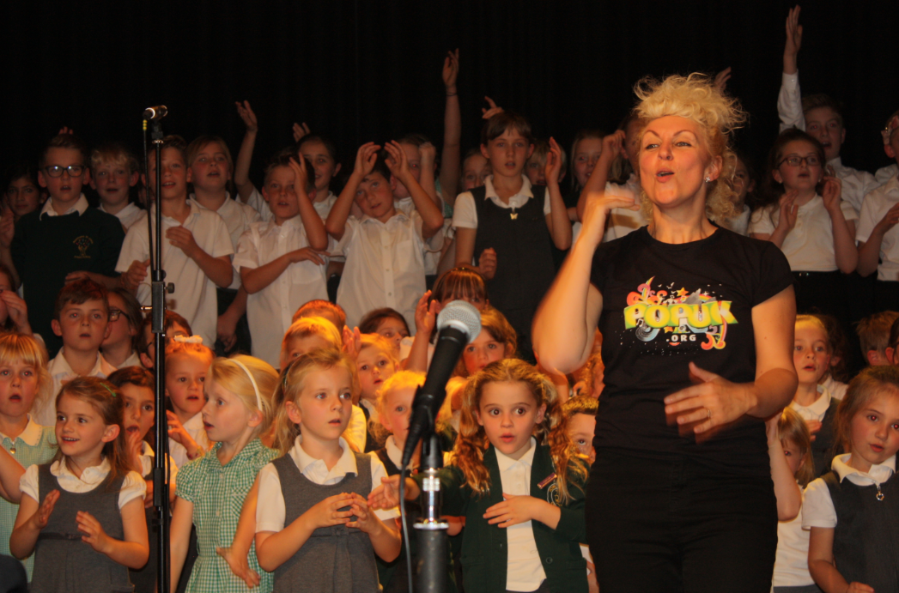

Behaviour in school

It is vitally important to us that every child at RSJ feels valued whilst at school. Our behaviour management policy uses a framework of positive reinforcement, and we work closely with home at all times, to ensure the best outcomes for every child.

Class Charters
Every year, children work with their class to draw up class charters based on the school’s core values of Love, Joy and Responsibility. These charters outline the behaviours the children are expected to show around school and, in following these, the majority of children respond well to the guidance of staff and the example set by other children.

Bullying
Bullying is completely unacceptable, and any incidents of bullying are treated with the utmost seriousness. Each year, the Young Governors Behaviour team develop an anti-bullying statement and present it to the rest of the school.

Policies
Copies of our Behaviour Policy, anti-bullying statement and the Home/School Agreement can be obtained from the school office or from the school website.

Getting to school

Walking
We would encourage parents to walk to school with their children wherever possible. Walking to school will reduce the difficult issue of traffic congestion around the three school entrances. If a child does walk to school unaccompanied by an adult, we will need written parental consent for them to do this. We have a road crossing patrol officer who helps the children cross the road safely.

Cycling
Cycle racks are available for the secure storage of bikes, and we recommend that children successfully complete the Bikeability scheme offered at RSJ before they begin cycling to school. Again, if children cycle to school unaccompanied by an adult, we will need written parental consent for them to do this.

By car
We ask that when bringing children to school by car parents park with courtesy towards our neighbours by not parking in driveways or blocking them. Also, we ask that parents do not block the school gates or use the school car park at the beginning or end of the day.

The school day

Opening Hours
Morning school 8.45am – 12.10 (12.00 for KS1)
Afternoon school 1.10pm – 3.10pm
The school day includes a daily act of collective worship, a 15 minutes morning playtime and an hour for lunch. The younger children may take additional play breaks at other times as appropriate.
Classroom doors open at 8.35am each morning.

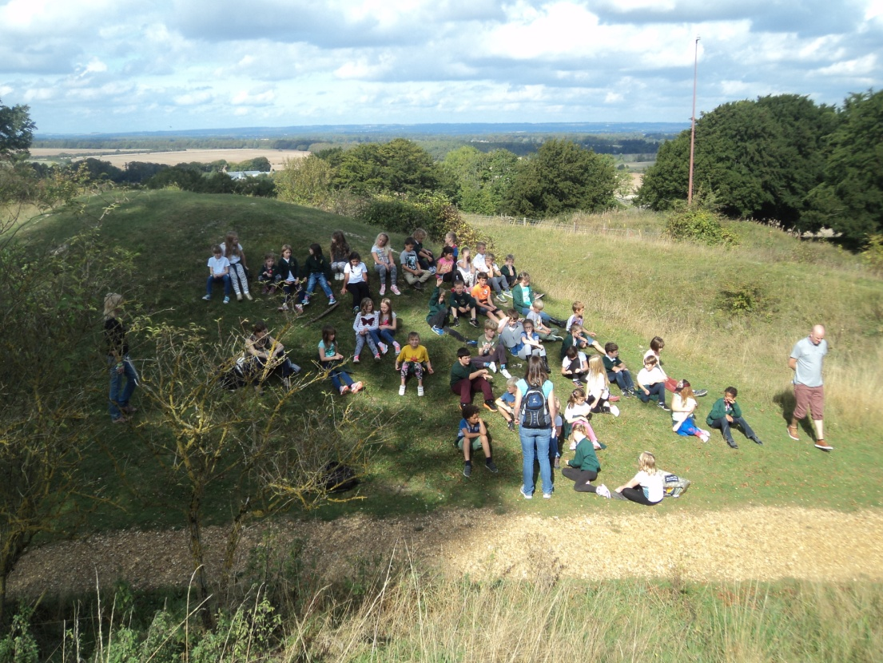
Health and Well-being

RSJ is a Healthy School and to this end takes the health and wellbeing of all children seriously. This encompasses both the physical and emotional aspects of healthy living.

We have a number of children with nut allergies. As a result, we have made the decision, as a school, to be a nut free zone – so please ensure that your child’s lunch does not contain any nuts or nut traces!

School lunches:
At RSJ we actively promote healthy eating. HC3S provides our school meals which are currently available at a cost of £2.00 per day. We ask that you pay in advance for meals taken. Any credits for meals not taken can be carried forward

If you think your child may be entitled to free school meals, please speak to our Admin Office for details or use the online checking service at: www3.hants.gov.uk/caterers/hc3s-freeschoolmeals.

Packed lunches:
Children may bring packed lunches to school. We request that these are packed in clearly labelled lunch boxes.

Water is provided at each table, or you may choose to provide a carton of juice stored within the lunch box. We do not permit children to bring in fizzy drinks, cans or glass bottles for safety reasons and request that sweets and chocolates do not form part of a packed lunch.

Break-time snacks
We ask that any playtime snacks brought in from home are healthy (e.g. fruit, vegetables, bread roll, cheese). Chocolate, sweets, crisps or other highly processed foods are unacceptable as a snack.
Children in EYFS/KS1 (Years R – 2) are offered free fruit and vegetables at break-time as part of a Government health initiative. KS2 children (Years 3-6) are able to purchase a range of healthy snacks from the kitchen.

School clubs and extra-curricular activities
We believe that getting involved in extra-curricular activities can really enhance a child’s experience of school. As such, we work hard to offer a wide range of engaging and high quality activities for children to get involved with.
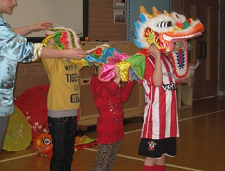
Emergency contact numbers and arrangements for collection must be provided for children to attend after-school clubs.

Sports
We offer a wide range of sporting activities. During the year, these include karate, netball, football, athletics, cross-country, tennis, tag- rugby, cricket and rounders clubs. Children in Year 5/6 are also offered the opportunity to take part in the Bikeability Scheme, which raises children’s awareness of road safety, supporting them in safe cycling/walking.

Music
In addition to curriculum music lessons, children have the opportunity to take violin, guitar and keyboard lessons with visiting music staff.

Other
Some of the other clubs we run during the year include: cooking, street dance, ground force (gardening), Pokemon, library, writing, storytelling, friendship, art, choir, homework and ICT.

Young Governors (School Council)
Once a child reaches Year 2, they have the opportunity to become a Young Governor. Young Governors work as a team on a variety of school improvement activities alongside our adult Governors. Our current Young Governors have worked with: Hampshire’s Strategic Landscaping Team to develop and improve the school grounds; the headteacher to develop the school’s vision and values and the Hampshire Road Safety team to develop a school travel plan. The Young Governors also get involved in organizing fund raising activities and working alongside the deputy head to develop and improve the behaviour policy.

Educational Visits
We believe that educational visits and off site activities are of particular value at primary school, as they enrich the curriculum in a way that we cannot do in school. These visits often form the most vivid and positive memories a child has of their education.
As such, we are passionate about making as extensive use of such visits as possible – and about ensuring that these are accessible for children.
We also arrange for visitors to come into school and share their knowledge and skills with the children.

Residentials
We provide the opportunity for children to go on residential trips once they reach KS2. These visits really improve children’s team work skills and help them to become more independent. We have long standing relationships with all the places we take children on residential – and the activities the children take part in are educational, fun, purposeful and really valuable in developing self esteem and confidence.

Community Links
The school enjoys its links with the local community – the local minister Rev Julian Williams leads weekly collective worship and St John’s Church is used throughout the year for visits and worship.
We encourage links with our two local pre-school groups – St John’s (Rownhams) on the church site and Horns Drove, located on the school site. Children from our local playgroups are welcomed at school events prior to their starting in Year R.
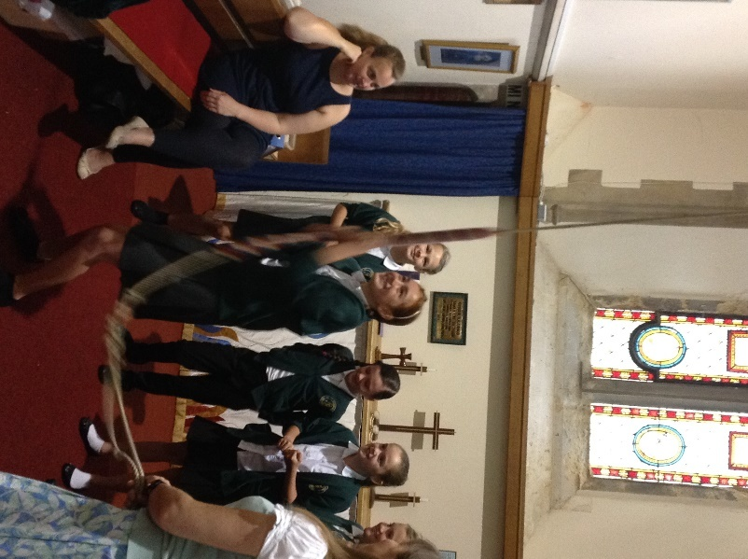
During their first year of school, all YR children take part in a Starters’ morning at St John’s church, whilst in Y6, the Leavers’ day of activities marks the children’s ‘moving on’ from our school, recognising their hopes for the future.
Rownhams St John’s is a feeder school for The Mountbatten School, Romsey: staff from the school meet regularly to help curriculum continuity and progression across our schools and there are strong sporting links within the pyramid of schools. Both staff and students from Mountbatten help provide a range of sporting activities throughout the year.
Our school has also developed links through the Romsey Diocese with Muramba Valley School in Rwenzori Province, Uganda, with regular fundraising to support the school’s development. The school also raises funds for Southampton City Mission, Operation Christmas Child and Children in Need with other specific charities being nominated each year.

Moving through school

Starting school in Year R

Is my child ready?
We understand that all children are at different stages of their development when they start school, but we do ask that they:
- Are able to use the toilet independently
- Are usually dry during the day
- Have some independence in dressing and feeding themselves
- Are able to communicate their needs.

How will I know what to expect?
We do a number of things to ensure that you and your child are ready to start school in September, most of which happen during the summer term before your child is due to join us. For example:
- We hold a meeting for new parents. This meeting gives parents an opportunity to meet our amazing team, have a tour of the school, familiarise themselves with our routines and ask any questions they may have.
- The Reception class teachers (and their support team) will arrange a home visit – something we have found really useful as it allows parents and child to meet these really important people in comfortable and familiar surroundings.
- We invite all children to join us at school for a number of pre-start sessions. We have found that these sessions help children to feel more comfortable with the environment, and more confident when they actually start school.
- Once the children join school, a Year 6 buddy will support them as they get to know school routines

Moving to RSJ from another school
Children who are transferring to RSJ from another school are encouraged to visit the school and spend some time with their new class before starting. Class teachers will ensure that children become familiar with school and class routines quickly and will choose some children to look out for your child, acting as guides during the transition period.

Moving from RSJ to another school
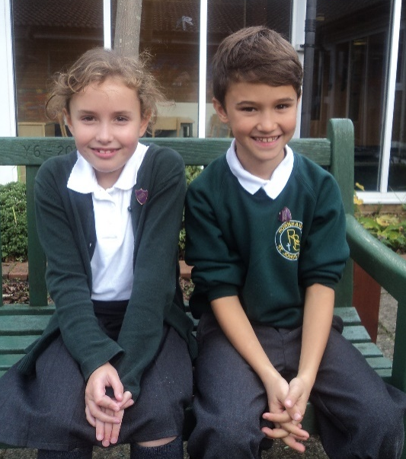
The records of a child moving from RSJ will be forwarded to the child’s new school and where necessary the class teacher or headteacher will have a conversation with the receiving school to discuss behaviour and academic achievement.

Moving on to secondary school
Early in Year 6, parents will receive a booklet outlining options for secondary education in the area and the procedures for application. They will also be invited to visit both during the school day and in the evening.
The majority of our children move on to Mountbatten School at the end of Year 6 (KS2). A comprehensive induction programme has been developed to support Year 6 children in their transfer to this school. This includes an Induction Day and Parents’ Evening during the Summer Term.
We provide Mountbatten with full details of children’s progress and achievements prior to their admission into Year 7.

Equipment and resources

Uniform
We ask all children to wear our uniform – it helps develop pride in our school and a sense of collective belonging. Uniform is available from the Skoolkit (Eastleigh/Totton) – and full details are available from www.skoolkit.co.uk.
Our uniform colours are predominantly dark green/grey and should be selected from the following items
Autumn/Winter/spring | Summer
Grey/black school trousers | Grey/black school trousers
Grey skirt/culottes/pinafore dress | Grey short trousers/skirt/culottes
White or green polo shirt* | Green/white checked dress
Green sweatshirt/jumper/cardigan* | White or green polo shirt
Black school shoes | Green sweatshirt/jumper/cardigan*
Bookbag | Black school shoes
 | Bookbag

* Available with school logo
Bookbags are available to order from the school office.
We also place great emphasis on children’s overall appearance. They should always look smart. This means that jewellery (other than a watch and pair of stud earrings), make up and other decorations are not allowed; hairstyles should not be extreme and long hair should always be tied back.
At times, children may need to bring an overall to protect their uniform during art/craft activities. An old shirt, cut to size and clearly named works perfectly.

PE Kit
We have a specific PE kit, which children are expected to wear, as follows:
PE Kit
T-shirt in house team colours*
Black shorts
Plimsolls/trainers
Tracksuit/jogging bottoms for cold weather
Drawstring bag*
* Available with school logo

Mobile phones
Children are discouraged from bringing mobile phones into school because of the risk of damage or theft. If a child does bring a phone in they are expected to hand it to the office to store during the day. However, the school can accept no responsibility for loss or damage.

Lost property
Lost property is usually handed in to the main office. There are boxes of mislaid school uniform in cloakroom areas.

Illness and medicines

Child becomes ill at home
If your child becomes ill, let the school know via telephone on the first day of the illness so we can record their absence appropriately. Your child should be fully recovered before they return to school, and able to take part in school activities.

Child becomes ill whilst at school or has an accident
Accidents may happen from time to time, we carry out risk assessments to endeavour to establish safe working practice with all activities.
If a child becomes ill or has an accident whilst at school, they will be risk assessed and looked after by school staff and every effort will be made to contact you.
It is essential that we have several up-to-date emergency numbers to enable us to contact you.
If your child has an

Infectious Diseases:
Some childhood ailments require a period of absence from school. There are guidelines for each type of infection and the school office will be able to advise parents of the requirement for a period of absence even though a child may seem well.

School Nurse
The School Nurse for the local area monitors children’s hearing, sight, height and weight. She is available to speak to parents and children at regular drop in sessions. Please contact the school office for more information.

Administration of medication at school

Prescribed medication
On occasion, children may still require medication on their return to school. If this is the case, please deliver the medication to the school office and complete the form they give you. Members of staff are only able to give children prescribed medication. If you prefer, we are happy for you to come into school to administer medication to your child.
There are strict rules and procedures for the administration of medicines in school. Forms and detailed guidance can be found on the school website.

Asthma
If your child is asthmatic please let us keep an inhaler or medication in school for supervised use during the day.
All medication, including inhalers, are kept securely in the medical room.

the home-school partnership

Family learning

Children benefit tremendously from parental involvement and interest in their school work. Parents will be notified of the frequency and amount of homework suggested for the age group in the Parents’ Information Evening each September.
We provide each family with a home/school partnership agreement, which outlines the contract encouraged between parents/children and the school – in order to help us all – but most of all the children.

Communication
We encourage all parents to keep in contact with the school. School is a hugely important part of a child’s life – and parents know their children best!

Newsletters
We email a weekly newsletter which will keep parents up to date with school activities and will give ‘advance warning’ of key dates, assemblies, concerts, sporting events and annual events.

Website
Our website (www.rownhams.hants.sch.uk) is regularly updated and contains a wealth of information about life at our school! Curriculum overviews, home learning activities and details of celebrations for parents and carers are just a few examples.

Other ways of keeping in touch
We also use a number of other ways of giving parents key messages, including:
- Text and email messages – up to date mobile and email addresses needed please!
- Dojo messages from class teachers (electronic behavior management system)
- Questionnaires
- Pre-school meetings
- Parent’s information evenings (Autumn and Spring)
- Mid-year progress reports
- Annual reports
If parents have any concerns, they are encouraged to come in and speak to someone. Our office staff are friendly and approachable and happy to help. We also have an ‘open-door’ policy. This means that parents are always more than welcome to come and speak to the teachers or the headteacher/deputy headteacher. If we cannot speak immediately, we will always arrange a mutually convenient time!
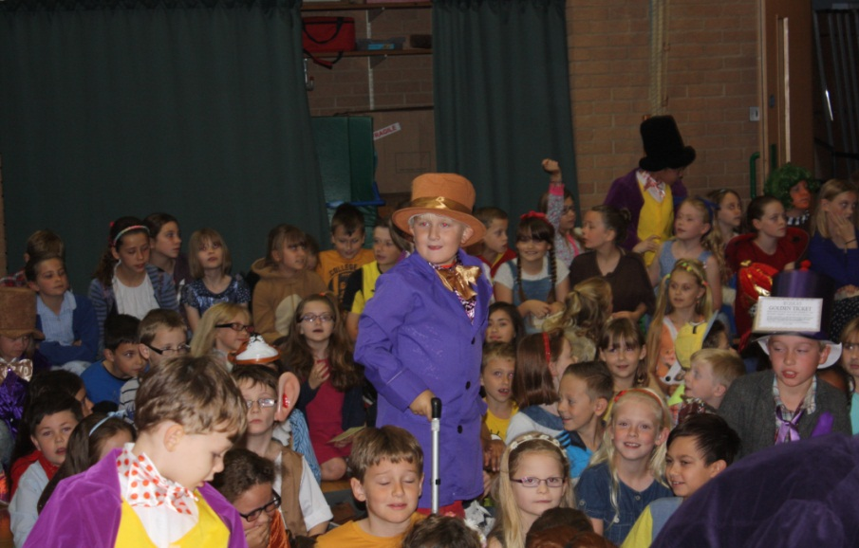

A child’s school records
Hampshire school keep careful records on the progress and development of every child. Parents may, by arrangement, see your child’s records. However, you may find it more beneficial to speak to your child’s teacher about progress and effort.

Rownham’s school Association – FORCE

We have a well-established School Association (originally set up in 1967). It aims to:
- Promote cooperation between all associated with the school
- Successfully fundraise to provide extra equipment and resources for the children of the school
- Encourage interest and support for the aims and ideals of our school.
FORCE run a wide variety of social activities (e.g. discos, fairs, quiz nights and raffles) over the course of the year which provide an excellent way of getting involved with the school and getting to know other parents.
The committee meet regularly – and they encourage all parents to come along. New faces, an extra pair of hands and some fresh ideas are always welcome!
FORCE can be contacted through the school office.

Helping out in school

The adults who help in our school on a voluntary basis are hugely valued by both staff and children. Activities range from reading with children, to helping with craft activities, to playing games with children, to cooking with small groups.
All offers of help are welcomed. If you would like to get involved, please contact your child’s teacher or the school office, who will arrange for you to have an induction. To ensure our children are safe, we ask all volunteers to complete an application form, provide references and complete a DBS check before working in school. We appreciate that this takes some time – but please bear with us – it is worth it!

leadership and management

School Performance

SCHOOL DATA
Phase and Subject | Description of data | Percentage  /Point score | Comparison to National/County
EYFS | Good Level of Development (GLD) | 90% | Consistently well above national and county  10% rise on last year’s data
 | Exceeding GLD | 22% | Well above national
Phonics Screening  Check | Year 1 | 93% | 12% above county and national  3 year upward trend
 | Year 2 retakes | 83% | 14% above national and county
Year 2  Reading | At expected standard or above (EXS+) | 80% | In line with county  6% above national
Year 2  Reading | At Greater Depth (GDS) | 36% | 7% above county  13% above national
Year 2 Writing | At expected standard or above (EXS+) | 77% | 7% above county12% above national
Year 2  Writing | At Greater Depth (GDS) | 15% | In line with county and national data
Year 2  Maths | At expected standard or above (EXS+) | 77% | 2% above county  7% above national
Year 2  Maths | At Greater Depth (GDS) | 25% | 7% above county and national
Year 2  RWM | At expected standard or above (EXS+) | 74% | 9% above county  14% above national
Year 2  RWM | At Greater Depth (GDS) | 10% | In line with county and national
Year 6  Reading | Average Scaled Score | 106 | 2 points above county and 3 points above national
Year 6  Reading | At expected standard or above (EXS+) | 92% | 21% above county and  26% above national
Year 6  Reading | At Greater Depth (GDS) | 23% | 4% above national
Year 6  Writing (TA/Moderated) | At expected standard or above (EXS+) | 92% | 12% above county  18% above national
Year 6  Writing (TA/Moderated) | At Greater Depth (GDS) | 32% | 17% above greater depth
Year 6  Maths | Average Scaled Score | 103.3 | In line with county and national
Year 6  Maths | At expected standard or above (EXS+) | 75% | 3% above county  5% above national
Year 6  Maths | At Greater Depth (GDS) | 15% | 2% below national
Year 6  GPS | Average Scaled Score | 106.3 | 2 points above county and national
Year 6  GPS | At expected standard or above (EXS+) | 87% | 13% above county and national
Year 6  GPS | At Greater Depth (GDS) | 30% | 7% above national
Year 6  RWM | At expected standard or above (EXS+) | 64% | 6% above county  11% above national
Year 6  RWM | At Greater Depth (GDS)

Follow this link for the school’s Ofsted data:
https://www.compare-school-performance.service.gov.uk/school/116311

OFSTED
The most recent Ofsted Inspection (February 2013) commented positively:
“Pupils achieve well. Good teaching over time has enabled pupils to make good progress regardless of their starting points. Pupils’ behaviour is good. Pupils feel safe in school and are well looked after by the adults who work with them. Reading is a strength of the school. Pupils read with increasing confidence and fluency as they move through the school. Progress in reading is good. The governing body monitors the work of the leadership team closely and provides the challenge to ensure pupil outcomes improve further. Teachers plan activities that pupils find interesting and meaningful, and this helps them to make good progress. The improvements in the school that have taken place since the last inspection have been made secure by several senior leaders who have ensured that pupils’ attainment over time has risen. The current leaders have a clear programme to continue these developments and demonstrate the capacity of the school to improve further.”
The full Ofsted Inspection report (February 2013) may be read by following this link or the link on the school website:
http://reports.ofsted.gov.uk/inspection-reports/find-inspection-report/provider/ELS/116311

School Development Plan

There are four key Areas for Development within the school development plan. These are as follows:
- Effectiveness of leadership and management
- Quality of teaching, learning and assessment
- Personal development, behaviour and welfare
- Outcomes of pupils
- Effectiveness of Early Years provision
Effectiveness of Leadership and Management | - To develop new leadership team so that capacity of leadership is maximised enabling sustainable school improvement
Quality of Teaching and Learning | - To ensure that the quality of teaching and learning is consistently good or better.
Personal Development, Behaviour and Welfare | - To develop the children’s understanding of what a good learner is
Outcomes | - To raise both attainment and progress for all children in reading, writing and mathematics
EYFS | - To develop a teaching and learning model that gives children opportunities for learning that is either teacher led, teacher initiated or child initiated

The Governing Body
The governing body acts as a critical friend to the leadership team of the school – supporting and challenging them to help improve the school further. They have a wide range of responsibilities, including:
- Establishing, alongside the headteacher, the aims of the school and how to improve standards of education.
- Issuing policies as required by legislation.
- Agreeing and reviewing the School Improvement Plan with the headteacher and school staff.
- Helping decide how to spend the school budget
- Acting as a link between the community and the school
- Drawing up and monitoring action plans following OFSTED inspections
- Reviewing Special Education Needs (SEN) provision
- Complaints, admissions, discipline and attendance
- Monitoring Equal opportunities and inclusion.
As part of these duties, governors visit the school, talk and work with children and staff and take part in various school improvement evaluation and monitoring activities.

Meetings
The Full Governing Body (FGB) meets at least six times a year.
Each governor also takes an active role in either the Standards, Resources or the Pay and Personnel committee. Foundation governors also work as a group to promote the characteristics required of a church school.
Minutes of meetings are available from the school office.

Our Governors
The Governors and the Clerk can be contacted through the school office.
Position & Committee(s) | Name | Type of governor
Chair – FGB | Andrew Brown | Foundation Governor
Vice Chair – FGB  Chair – Standards Committee  Headteacher Performance Management | Danny Hyam | Parent Governor
Headteacher Performance Management; Standards | Wendy Rees | Parent Governor
Chair of both Pay and Personnel & Resources | Fran Jones | Foundation Governor
Foundation | Rev. Julian Williams | Foundation Governor
Chair – Foundation Committee; Resources | Jen Ball | Foundation Governor
Training Liaison Governor, Standards | Jane Cotton | Co-opted Governor
Standards | Jane Smith | Co-opted Governor
 | VACANCY | Local Authority Governor
Standards | Ros Murch | Co-opted Governor
Resources | Allan Symmons | Co-opted Governor
Resources committee | Simon Warner | Staff Governor
All committees | Gwynne Kynaston | Headteacher
 | Pam Leech | Clerk to Governors
All Governors on Rownhams St Johns Primary CE School Governing Body have completed the required Declaration of Interests form.
All Governors confirmed that they have no direct pecuniary interests in any company/organisation with which the school may do business with.
In addition at each Governor meeting there is a standing item on the agenda inviting Governors to declare a personal/pecuniary interest in any business at the meeting. Any such declarations are recorded in the minutes.

Access to Official Information

The following are all available from the school office:
- Circulars, administrative memoranda and statutory instruments sent to schools by the Department for Education (DfE).
- Policy statements, including:
  - Behaviour policy (also available on website)
  - Complaints procedure (also available on website)
  - Charging policy (also available on website)
- Agreed (county) syllabus for RE (also available on website)
- Curriculum information (also available on website)
There is also a wealth of information on our website, so we would encourage you to take a look!

appendix 1: Term dates

Academic year 2016-17

Autumn Term

First Half Term 07.09.16 - 21.10.16

Second Half Term 31.10.16 - 16.12.16

Spring Term

First Half Term 03.01.17 – 17.02.17

Second Half Term 27.02.17 – 07.04.17

Summer Term

First Half Term 24.04.17 – 25.05.17

Second Half Term 05.06.17 – 21.07.17

Professional Training Days
The school is closed for five professional training days each academic year. These days help us to ensure that our team are proving the best possible education for your children. The dates of these training days will appear on every school newsletter, as soon as dates are agreed by the governing body.

